 |  |  | 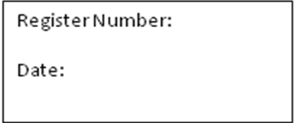
ST. JOSEPH’S COLLEGE (AUTONOMOUS), BANGALORE-27
MSW - II SEMESTER
SEMESTER EXAMINATION: APRIL 2018
SW 8415 – Social Welfare Administration
Time- 2 ½ hrs |  |  | Max Marks-70
This paper contains one printed page and has two parts.

PART : ONE
Answer any FIVE of the following: 5X10 = 50 Marks
- Highlight provisions of Foreign Contribution Regulation Act (FCRA).
- Define Social Welfare Administration. What are the principles of Social Welfare Administration?
- Highlight the importance of accountability and transparency in the management of organizations.
- What are features of NGOs? Describe the role of NGOs in good governance and social justice.
- Define Planning. Describe the principles of involved in programme-planning.
- Write a note on the personality of a project manager.
PART : TWO
Answer any ONE of the following: 1X20 = 20 Marks
7. Write a note on the steps involved in the planning of participatory projects.
8. Describe the purpose, stages and criteria for evaluating projects.

