 |  |  | 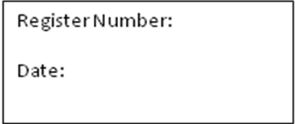
ST. JOSEPH’S COLLEGE (AUTONOMOUS), BANGALORE-27
M.S.W. - IV SEMESTER
SEMESTER EXAMINATION: APRIL 2018
SWDE 0515 – URBAN COMMUNITY DEVELOPMENT
Time- 2 ½ Hours |  |  |  | Max Marks - 70
This paper contains ONE printed page and TWO parts

PART - A
Answer any FIVE of the following questions: 10 x 5 = 50 Marks
- What are the features of urban communities?
- Describe the theories relating to the process of urbanization.
- Explain the concept and objectives of Urban Community Development.
- Write a note on functions of urban administration.
- Write a note the problem of Urban pollution.
- Explain the role of Urban Community Development Social Worker working in an NGO in addressing urban poor issues.
PART - B
Answer any ONE of the following questions: 1X 20 = 20 Marks
- Explain various programmes and policies of urban Community Development.
- Highlight the problems of Urban Communities and suggest measures to overcome them.

