 |  |  | 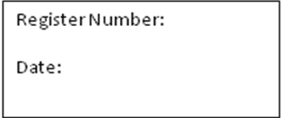
ST. JOSEPH’S COLLEGE (AUTONOMOUS), BANGALORE-27
MSW - IV SEMESTER
SEMESTER EXAMINATION: APRIL 2018
SW 0215 – HR-Corporate Social Responsibility
Time- 2 ½ Hours |  |  | Max Marks-70
This paper contains ONE printed page and TWO parts.

PART : ONE
Answer any FIVE of the following: 5X10 = 50 Marks
- Explain the importance of Business Ethics.
- What are the main provisions of the Companies Act of 2013 regarding CSR activities?
- Mention the different types of companies and their advantages.
- Define the term ‘Corporate Governance’. Explain the principles and models of Corporate Governance.
- Define ‘Ethics’ and ‘Social Responsibility’. Mention different types of Social Responsibility in Business.
- Give one example of CSR initiatives of any Indian Company in your vicinity.
PART: TWO
Answer any ONE of the following: 1X20 = 20 Marks
- Describe the concept and principles of ‘Corporate Social Responsibility’ in Business Ethics.
- Cite the arguments for and against CSR activities in a business enterprise.

