
Register Number:
DATE: 01-04-2019
ST. JOSEPH’ S COLLEGE (AUTONOMOUS), BANGALORE - 27
SEMESTER EXAMINATION – APRIL 2019
B.Sc. CBCS – IV Semester
ELOE 4116 - Number System and Logic Circuits

Time: 1 Hour and 30 Minutes Max. Marks: 35
This question paper has THREE parts and THREE printed pages.
PART – A
CHOOSE THE CORRECT ANSWER FROM THE OPTIONS GIVEN 10X01=10
1. Way of representing numbers and alphabets is found in _________
a) binary notation b) decimal notation c) hexadecimal notation d) octal notation
2. A 0101 series is known as
a) Bit b) Byte c) Nibble d) Hex
3. Which code is also called as cyclic code?
a) BCD code b) Gray code c) 8421 code d) Excess -3 code
4. The next number in the counting of hexadecimal number EEEE is
a) EEE0 b) EEEF c) 0EEE d) FEEE
5 _______ is called Universal gate.
a)OR gate b) AND gate c) NOR gate d) NOT gate
6. The symbol for AND gate.
a) b) c) d)
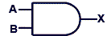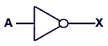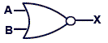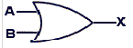

7. The ASCII code is a ______ bit code
a) 5 b) 6 c) 7 d) 8
8. IC _______ is called JK Flip Flop.
a) 7486 b) 7400 c) 7476 d) 7490
9. How many clock pulses required to shift a 4 bit number in a 4 bit SISO.
a) 1 b) 4 c) 8 d) 10
10. The decade counter needs _________ number of Flip Flops.
a) 10 b) 8 c) 6 d) 4

PART – B
11. Match the Following 05X01=05
a) Binary equivalent of 63 |  | i) NOT gate
b) 2’ s complement of 100001 |  | ii) Flip Flop
c) When EVEN number of inputs are high,  we get output high |  | iii) 111111
d) The only gate with ONE input |  | iv) XNOR gate
e) One bit memory device |  | v) 011111
 |  | vi) Counter

PART – C
Answer any TEN questions. 10X02=20
12. Convert (16) ₁₆ into decimal.
13. Subtract 27 from 138 using 2’s complement.
14. Write the circuit diagram for a 2 input OR gate and give its truth table.
15. What is EXCESS -3 code? Give an example.
16 Write the OR gate using NAND gate..
17. State De Morgan’s theorems.
18 Prove the Boolean identity.
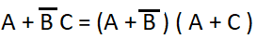
19. Write the output of the circuit given below.
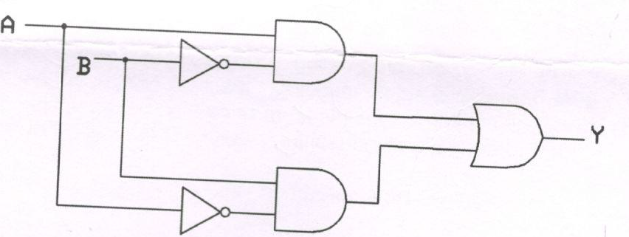

20 Write the symbol of a D Flip flop using SR Flip flop.
21. Write the logic circuit of a 4 bit PIPO shift register.
22. Write the truth table for a 4 bit Ripple Up Counter.
23. Expand ROM and EEPROM.

--------------------------------------------------------END------------------------------------------------------------
3.
ELOE 4116_A_19

