
Register Number:

Date: 22-04-2019
ST. JOSEPH’S COLLEGE (AUTONOMOUS), BENGALURU-27
B.Sc MICROBIOLOGY-VI SEMESTER
SEMESTER EXAMINATION - APRIL 2019
MB 6116- Food and Fermentation Technology

Time-2 ½ hrs Max Marks-70
This paper contains 2 printed pages and 4 parts
- Answer any Five of the following 5x3=15

1. Write a note on Osmotic dehydration with an example.
2. Classify Cheese based on the moisture content with examples.
3. Give the importance of wood smoke in food preservation.
4. What are Antifoams? List their uses with examples.
5. Write notes on the importance of Ion exchange Chromatography.
6. What is MBRT?
7. List the Principles of HACCP.
II. Answer any Five of the following 5x5=25
8. Discuss Pasteurization.
9. Give the schematic production of yoghurt and its importance.
10. Diagrammatically describe a typical fermenter.
11. Describe the sources of contamination of milk.
12. What are the chemical methods of cell disruption? Explain.
13. Discuss ‘Food as a substrate’ for the growth of microorganisms.
14. Write notes on Aflatoxins.

III. Answer any Two of the following 2x10=20
15. Describe the use of Chemicals in food preservation.
16. Explain the Biochemical activities in milk.
17. Describe Strain improvement using Mutations.

IV. Answer the following 1x10=10
18. Ingestion of contaminated food can cause serious illness. Hence to identify the
organism suspected food, serum, faecal matter, wound exudates are examined
for the toxins. Give the appropriate answers to a and b.
- If the incubation time in humans has been reported as 12-36 hours. Identify the organism for such an illness and describe its characteristics and symptoms.
- If the organism is gram positive, spore forming, aerobic, motile rod, producing the toxin in the gut region during its vegetative growth, Identify the organism, the symptoms of the disorder and the media used to isolate the organism.

ST. JOSEPH’S COLLEGE (AUTONOMOUS), BANGALORE-27
B.Sc MICROBIOLOGY-VI SEMESTER
SEMESTER EXAMINATION: APRIL 2019
MB 6116- FOOD AND FERMENTATION TECHNOLOGY

SCHEME
- Answer any Five of the following. 5x3=15

- Osmotic dehydration: definition with an example: 03 marks
Osmotic dehydration is an operation used for the partial removal of water from plant tissues by immersion in a hyper-tonic (osmotic) solution. The driving force for the diffusion of water from the tissue into the solution is provided by the higher osmotic pressure of the hyper-tonic solution. The diffusion of water is accompanied by the simultaneous counter diffusion of solutes from the osmotic solution into the tissue. Since the cell membrane responsible for osmotic transport is not perfectly selective, solutes present in the cells (organic acids, reducing sugars, minerals, flavors and pigment compounds) can also be leaked into the osmotic solution, which affects the organoleptic and nutritional characteristics of the product. Example: sugar / salt

- Classification of Cheese based on the moisture content with examples: 03 marks
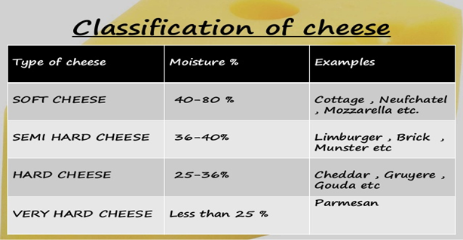

- Wood smoke in food preservation: 03 marks Smoking is the process of flavoring, browning, cooking, or preserving food by exposing it to smoke from burning or smoldering material, most often wood. Meat, fish are often smoked, alder is the traditional smoking wood, but oak is more often used now, and beech to a lesser extent, hickory, mesquite, oak, pecan, alder, maple, and fruit-tree woods, such as apple, cherry, and plum, are commonly used for smoking. Other biomass besides wood can also be employed

- Antifoams: definition and examples: 03 marks A defoamer or an anti-foaming agent is a chemical additive that reduces and hinders the formation of foam in industrial process liquids. The terms anti-foam agent and defoamer are often used interchangeably. Commonly used agents are insoluble oils, polydimethylsiloxanes and other silicones, certain alcohols, stearates and glycols. The additive is used to prevent formation of foam or is added to break a foam already formed.In industrial processes, foams pose serious problems. They cause defects on surface coatings and prevent the efficient filling of containers. A variety of chemical formulae are available to prevent formation of foams

- Importance of Ion exchange Chromatography: 03 marks Ion chromatography (or ion-exchange chromatography) is a chromatography process that separates ions and polar molecules based on their affinity to the ion exchanger. It works on almost any kind of charged molecule—including large proteins, small nucleotides, and amino acids. Uses: Clinical utility, Industrial applications, Drug development

6. MBRT: Definition and interpretation: 03 marks The methylene blue reduction test is based on the fact that the color imparted to milk by the addition of a dye such as methylene blue will disappear more or less quickly. The removal of the oxygen from milk and the formation of reducing substances during bacterial metabolism causes the color to disappear.
Class 1. Excellent, not decolorized in 8 hours.
Class 2. Good, decolorized in less than 8 hours but not less than 6 hours.
Class 3. Fair, decolorized in less than 6 hours but not less than 2 hours.
Class 4. Poor, decolorized in less than 2 hours.

7. Principles of HACCP: 03 marks Conduct a Hazard Analysis, Identify the Critical Control Points, Establish Critical Limits, Monitor CCP, Establish Corrective Action, Verification, Recordkeeping.
II. Answer any Five of the following. 5x5=25
8. Pasteurization: LTH: 62.8°C, HTST: 71.2 °C,UHT: 130°C
9. Schematic production of yoghurt: 03 marks, importance: 02 marks Yogurts can be
high in protein, calcium, vitamins, and live culture, or probiotics, which can
enhance the gut microbiota. These can offer protection for bones and teeth and
help prevent digestive problems. Low-fat yogurt can be a useful source of protein
on a weight-loss diet. Probiotics may boost the immune system.
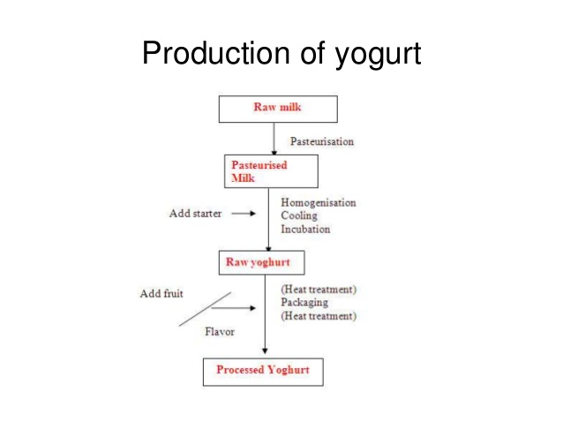

10. Diagram: 03, describe a typical fermenter: 02 marks.
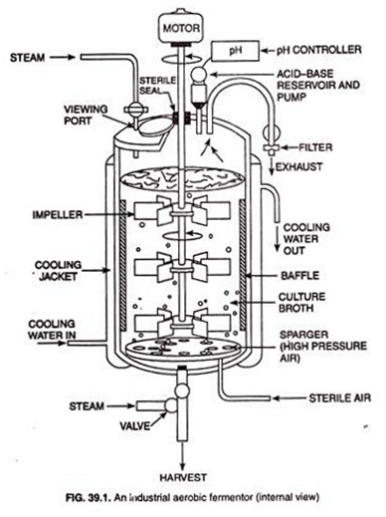

11. Sources of contamination of milk: 05 marks Interior of udder, Exterior of udder,
Coat of cow, Animal shed and surroundings, Milking staff, Milking equipment
(storage containers and transportation systems), Water supplies, Airborne
Contamination.
12. Chemical methods of cell disruption: 05 marks Organic solvents like alcohols,
ether or chloroform can disrupt cells by permeating the cell walls and membranes.
These solvents are often used (in combination with shearing forces) with plant
cells. EDTA (ethylenediaminetetraacetic acid) is a chelating agent which can be
used to disrupt gram negative microorganisms, since it chelates the cations,
leaving holes in the cell walls. Surfactants (commonly called detergents) disrupt
the distinct interface between hydrophobic and hydrophilic systems. Detergents
are used in cell lysis buffers and they help to solubilize membrane proteins and
lipids thereby causing the cell to lyse and release its contents. Widely used
detergents include Triton and sodium dodecyl sulfate (SDS).
Chaotropic agents, such as urea and guanidine, are also used for cell lysis. They
are capable of bringing some hydrophobic compounds into aqueous solutions.
They do this by disrupting the structure of water and making it a less hydrophilic
environment, and weakening the hydrophobic interactions among solute
molecules.
13. Food as a substrate for the growth of microorganisms: 05 marks: nutrients- macro
and micro, water/ moisture, pH, redox potential
14. Aflatoxins: source, organisms, toxin characteristics, sickness and symptoms
caused, detection: 05 marks Aflatoxins are a family of toxins produced by certain
fungi that are found on agricultural crops such as maize (corn), peanuts,
cottonseed, and tree nuts. The main fungi that produce aflatoxins are Aspergillus
flavus and Aspergillus parasiticus, which are abundant in warm and humid
regions of the world. Aflatoxin B1 and B2, produced by Aspergillus flavus and A.
parasiticus Aflatoxin G1 and G2, produced by some Group II A. flavus and
Aspergillus parasiticus Aflatoxin M1, metabolite of aflatoxin B1 in humans and
animals (exposure in ng levels may come from a mother's milk) Aflatoxin M2,
metabolite of aflatoxin B2 in milk of cattle fed on contaminated foods

III. Answer any Two of the following. 2x10=20
15. Chemicals in food preservation: any 4: 10 marks Sugar, Salt, Organic Acids-
Benzoic acid, Sorbic acid, Lactic acid, citric acid, acetic acid, Gaseous chemical
food preservatives/ leavening agents, Sulphur dioxide and sulphites,
Carbondioxide.

16. Biochemical activities in milk: 10 marks
(1) souring: Lactic acid bacteria which ferment lactose to lactic acid and other end products. (2) proteolysis: Proteolytic bacteria which degrade protein and cause bitterness and putrefaction (3) lipolysis: Lipolytic bacteria which degrade fats and produce lipolytic rancidity (4) Gassy fermentation: Gas producing microorganisms which cause cheese openness, floating curd in cottage cheese, and gassy milk. (5) Ropiness: Ropy bacteria cause stringy milk due to excretion of gummy polysaccharides. Usually ropy bacteria such as Alcaligenes viscolactis are undesirable. (6) Sweet curdling bacteria produce rennet-like enzymes which may coagulate milk.
17. Strain improvement using mutations: 10 marks Mutation: Spontaneous
mutation/Directed mutation
Selection: Rational Screening/ Random Screening
Chemical mutagenic agents: Alkylating agents, Base analogues, Nitrous acid
Physical mutagenic methods: UV, Microwave, X-ray, γ-rays
Mutants formed by mutation are grouped into 2 categories: i) auxotrophic mutants
& ii) mutants resistant to analogues.
Microorganisms usually have regulatory mechanisms that control the amount of metabolites synthesized, therefore suppression of regulatory mechanisms is necessary to develop the strains for higher yields. Microbial cultures which have multivalent mechanisms, concerted repression or feed-back inhibition may be used for strain development Mutants which have lost the ability to synthesize one of the end product capable of feed-back inhibition or repression is selected.

IV. Answer the following 1x10=10
18. Ingestion of contaminated food can cause serious illness. Hence to identify the
organism suspected food, serum, faecal matter, wound exudates are examined
for the toxins. There are two organisms given below for your Identification.
- If the incubation time in humans has been reported as 12-36 hours, Identify the organism for such an illness and describe its characteristics and symptoms: 06 marks
Clostridium botulinum: sources and characteristics of the organism, symptoms, foods involved, toxin characteristics, detection and treatment: 06 marks
- If the organism is gram positive, spore forming, aerobic, motile rod, producing the toxin in the gut region during its vegetative growth, Identify the organism, the symptoms of the disorder and the media used to isolate the organism.
Bacillus cereus: causing the diarrhoeal symptoms, PEMBA media or phenol egg yolk polymyxin agar: 04 marks

